LAB # 03

OBJECTIVE
Implementation of Class.
Object Creation

Overview of Classes
A Class Is an Active Data Structure

A class is a data structure that can store data and execute code. It contains the following:
• Data members, which store data associated with the class or an instance of the class. Data Members generally model the attributes of the real-world object the class represents.

• Function members, which execute code. Function members generally model the functions and actions of the real-world object the class represents.

A C# class can have any number of data and function members. The members can be any Combination of nine possible member types. These member types are shown in Table 4-1.
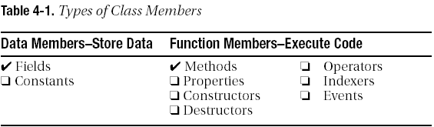

Declaring a Class
The class declaration provides the following:
• The class name
• The members of the class
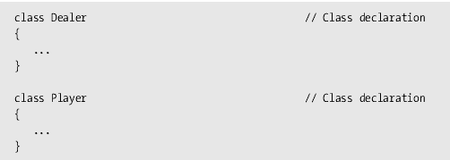
• The characteristics of the class
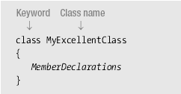
Note: Class declaration referred to as a “class definition”
Class Members
Fields and methods are the most important of the class member types. Fields are data members and methods are function members.

Fields
A field is a variable that belongs to a class.
• It can be of any type, either predefined or user-defined.
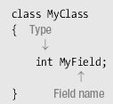
• Like all variables, fields store data, and have the following characteristics:
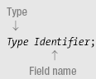

Methods
A method is a named block of executable code that can be executed from many different parts of the program, and even from other programs. When a method is called, or invoked, it executes its code, and then returns to the code that called it.

Return type: This states the type of value the method returns. If a method does not return a value, the return type is specified as void.

Name: This is the name of the method.
Parameter list: This consists of at least an empty set of matching parentheses. If there are parameters), they are listed between the parentheses.

Method body: This consists of a matching set of curly braces, containing the executable code.
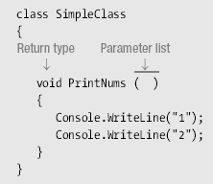

Class
A class is simply a representation of a type of object. It is the blueprint/ plan/ template that describe the details of an object. A class is the blueprint from which the individual objects are created. Class is composed of three things: a name, attributes, and operations.

Declaring Classes
Public class Employee
{
//Fields, properties, methods and events go here...
}

Object Creation

Employee secretary; // declares secretary
secretary = new Employee (); // allocates space

Employee secretary = new Employee(); // does both

But the secretary is still "blank"
secretary.name = "Adele"; // dot notation
secretary.birthday (); // sends a message

Object-creation expression
The keyword new

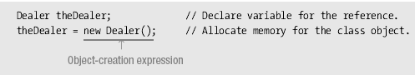

Example # 01
using System;
namespace example1
{
class example1
{
public int v = 1;
}

class Program
{
static void Main(string[] args)
{
example1 e;
e = new example1();
Console.WriteLine("Value of integer is "+e.v);
Console.ReadKey();
}
}
}

Example # 02
using System
namespace example2
{
class temp
{
public float high;
public float low;

public float average()
{
return ((high + low) / 2);
}
}
class Program
{
static void Main(string[] args)
{
temp tobj = new temp();
tobj.high = 40;
tobj.low = 10;

Console.WriteLine("Low Temp is " + tobj.low);
Console.WriteLine("High Temp is " + tobj.high);
Console.WriteLine("Average Temp is " + tobj.average());
Console.ReadKey();

}
}
}

Example # 03
using System;
namespace example3
{
class Building
{
public int Floors; // number of floors
public int Area; // total square footage of building
public int Occupants; // number of occupants

}
class BuildingDemo
{
static void Main()
{
Building house = new Building(); // create a Building object
int areaPP; // area per person

house.Occupants = 4;
house.Area = 2500;
house.Floors = 2;

areaPP = house.Area / house.Occupants; // Compute the area per person.

Console.WriteLine("house has:\n " + house.Floors + " floors\n " + house.Occupants + " occupants\n " +
house.Area + " total area\n " + areaPP + " area per person");
Console.ReadKey();
}

}

}

Task
- Write the output of the following program.
using System;

public class Book
{
public string Title;
public string Author;
public short YearPublished;
public int NumberOfPages;
public char CoverType;
}

public class Exercise
{
static void Main()
{
var First = new Book();

First.Title = " Turbo C ";
First.Author = "Robert Lafore";
First.YearPublished = 1996;
First.NumberOfPages = 872;
First.CoverType = 'H';
Console.WriteLine("Book Characteristics");

Console.Write("Title: ");
Console.WriteLine(First.Title);
Console.Write("Author: ");
Console.WriteLine(First.Author);
Console.Write("Year: ");
Console.WriteLine(First.YearPublished);
Console.Write("Pages: ");
Console.WriteLine(First.NumberOfPages);
Console.Write("Cover: ");
Console.WriteLine(First.CoverType);
Console.ReadKey();
}
}

- Create a class student with a data members name, age, marks of English , marks of math, marks of science, total marks, obtained marks and percentage provide member functions CalculateTotalMarks and CalculatePercentage to calculate marks and percentage in main.

- Write a program that contains a class which has a method that takes user name as input and second functions which returns number of vowels present in it and Main program prints the number of vowels
- Create a rectangle class with two data members’ length and width Provide member functions to calculate the perimeter and area of the rectangle and a function square which returns true if the rectangle is a square otherwise it returns false.

- Write a class to simulate a bank account allowing for initialization, deposits, withdrawals, setting the interest rate, adding interest and giving the current balance. Provide some code to demonstrate the object in action

